|  |  |
| --- | --- |
| **Logo_Baru-Rasmi_UUM_02** | STIA1123: Programming 2 Semester 181School of Computing, CAS, UUM |
| Lab 2 | |
| 18/10/2019  Submission  24/10/2019 | |

Scenario:

Consider the following scenario:

“A food delivery company (FOODNINJA) need to computerized their current delivery system. They need the system to be able to store information of their 10 delivery personnel. The information needed are staff name, id, salary and branch.

1. Identify a class in the above scenario and draw UML diagram for the identified class.
2. Write a proper Class for (a).
3. Create an object array for (b). Make sure user can enter all information.
4. Finally print back all information in the object array to the screen.

Save the following into word document

* + Java class files and main class.
  + At least 3 print screen terminal application interface screenshot that describe input-process-output.

Make sure the source code is readable and the interface screenshot is clear.

upload to:

* UUM Learning
* <http://slumberjer.com/teaching/a192/stia1123/upload/>

**Late submission will be not accepted and tolerated and will be given 0.**

MAIN CLASS

package food\_ninja;

import java.util.Scanner;

public class FOOD\_NINJA {

public static void main(String[] args) {

Scanner scan = new Scanner(System.in);

Staff staff[] = new Staff[10];

for(int i=0 ; i<10;i++){

System.out.print("Write ID:");

String ID = scan.nextLine();

System.out.print("Write Name:");

String Name = scan.nextLine();

System.out.print("Write Salary:");

String Salary = scan.nextLine();

System.out.print("Write Branch:");

String Branch = scan.nextLine();

staff[i] = new Staff(ID,Name,Salary,Branch);

}

System.out.println("######## Thank You ########");

for(int i=0; i<10; i++){

System.out.println("Staff ID="+staff[i].getID());

System.out.println("Staff Name="+staff[i].getName());

System.out.println("Staff Salary="+staff[i].getSalary());

System.out.println("Staff Branch ="+staff[i].getBranch());

System.out.println("######## Thank You ########");

}

}

}

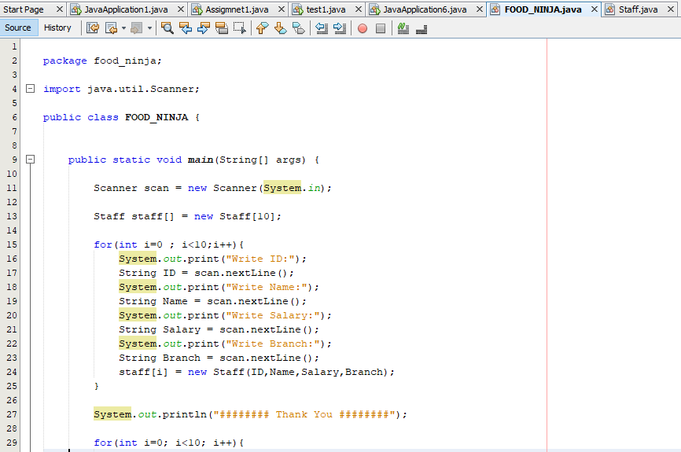

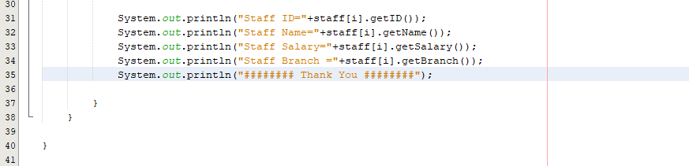

CLASS FILES

package food\_ninja;

public class Staff {

String ID,Name,Salary,Branch;

Staff(String ID,String Name,String Salary,String Branch){

this.ID = ID;

this.Name = Name;

this.Salary = Salary;

this.Branch = Branch;

}

String getID(){

return ID;

}

String getName(){

return Name;

}

String getSalary(){

return Salary;

}

String getBranch(){

return Branch;

}

void setName(String Name){

this.Name = Name;

}

void setSalary(String Salary){

this.Salary = Salary;

}

void setBranch(String Branch){

this.Branch = Branch;

}

}

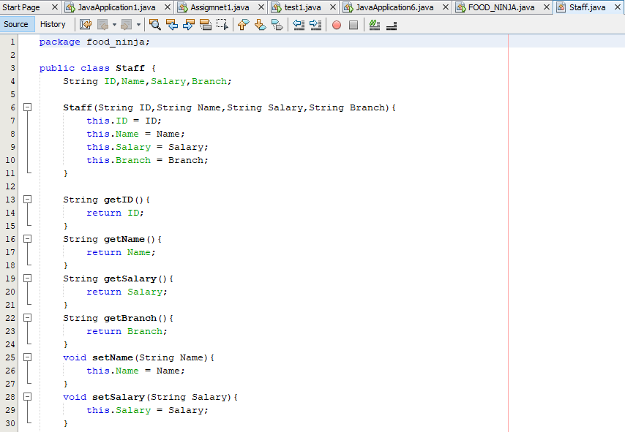

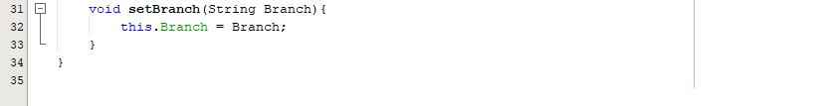

INPUT

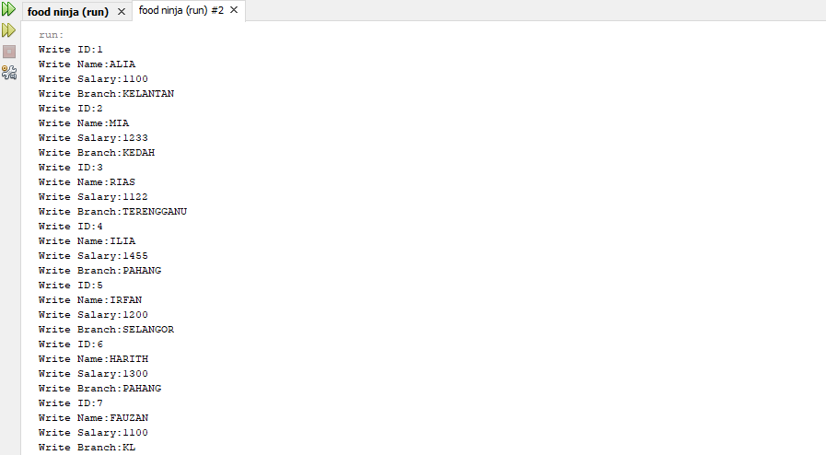

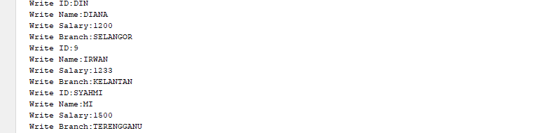

OUTPUT

